|  |  |
| --- | --- |
| Name | Umar Hayyat |
| Roll No | 2019-EE-360 |

**Lab NO 06**

**Loops**

**Objectives:**

In this lab,

* I will learn use of nested for loop.
* I will learn how we print stars in different pattern.
* I will learn how we print prime numbers.
* **Task 1:**

Use for loop to make the following shape:

* * * * * *

* * * * *

* * * *

* * *

* *

*

Note: use only one * with print.

**Code:**

public class Stars {

public static void main (String [] args) {

for(int i=6;i>=1;i--){

for (int j=0;j<i;j++){

System.out.print("* ");

}

System.out.println("");

}

} }

**Output:**

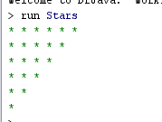

**Task 2:**

Write a program using for loop which displays all the prime numbers from 50 to 100.

**Code:**public class Prime

{

public static void main(String[] args) {

String prime = "";

for (int i = 50; i<= 100; i++)

{

int count=0;

for(int num =i; num>=1; num--)

{

if(i%num==0)

{

count = count + 1;

}

}

if (count ==2)

prime = prime + i + " ";

}

System.out.println("Prime numbers from 50 to 100 are :");

System.out.println(prime);

} }

**Output:**

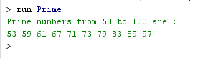

**Task 3:**

Make the following shape using for loop:

*

* * *

* * * * *

* * *

*

Challenge: use only one * with print.

**Code:**

public class Diamond {

public static void main (String [] args)

{

int count=0;

for(int i=1;i<=2*4-1;i++)

{

for (int j=count;j<=4;j++)

{

System.out.print(" ");

}

for (int k=1;k<=count*2-1;k++)

{

System.out.print("*");

}

if(i<4)

count++;

else

count--;

System.out.println("");

}

} }

**Output:**

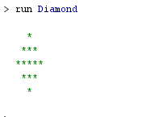

**Task 4:**

Write a program to check whether a number is a palindrome or not.

**Code:**

import java.util.Scanner;

public class Plindrom

{

public static void main (String [] args)

{

int remain,x,y,z=0;

Scanner num=new Scanner(System.in);

System.out.println("Enter any integer");

x=num.nextInt();

y=x;

while (x!=0)

{

remain=x%10;

z=z*10+remain;

x=x/10;

}

if (y==z)

System.out.println("It is Palindrome");

else

System.out.println("It is not Palindrome");

} }

**Output:**

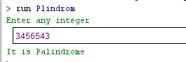

**Task 5:**

Write a program which breaks down an integer in segments and display each digit of the integer in new line.

**Code:**

import java.util.Scanner;

public class DigitsBreak {

public static void main(String[] args) {

int num, set, digit, count = 0;

Scanner roll = new Scanner(System.in);

System.out.print("Enter any integer :");

num = roll.nextInt();

set = num;

while(num> 0)

{

num = num / 10;

count++;

}

while(set > 0)

{

digit = set % 10;

System.out.println("Digit at "+ count+" is "+digit);

set = set / 10;

count--;

}

}

}

**Output:**

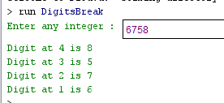

**Conclusion:**

In this lab, I learnt the use of nested loop. I also learnt that how we print different pattern of stars as I print the triangle and diamond pattern with stars. I also learnt that how we print or find prime numbers between any two integers as I print prime number from 50 to 100. Palindrome is a number that reads the same backward as forward e.g. 12321, 33333 etc. I also learnt that how we find or know that the entered integer is palindrome or not as I perform this.